Research methodology
Lecture 4
Topic 3. Means and methods of scientific research

1. Means of knowledge: material, informational, mathematical, logical, linguistic.
2. Classification of scientific research methods. Empirical and theoretical levels of cognition.
3. Theoretical methods of research (analysis, synthesis, comparison, abstraction, concretization, generalization, formalization, induction, deduction, idealization, analogy, modeling).
4. Empirical research methods (study of literature, documents and performance, observation, measurement, survey, method of expert assessments, testing, survey, monitoring, study and synthesis of experience, experiment, retrospection, forecasting).

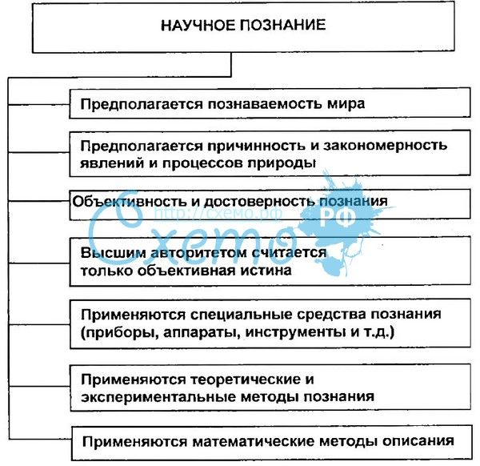

Means of scientific research (means of cognition)

1. During the development of science, means of knowledge are developed and improved: material, mathematical, logical, linguistic. In addition, recently, it is obvious that it is necessary to add information tools as a special class to them.
2. All means of knowledge are specially created means. In this sense, material, informational, mathematical, logical, linguistic means of knowledge have a common property: they are designed, created, developed, justified for certain cognitive purposes.

Средства
познания

Material means of knowledge

1. These funds are directly directed to the objects being studied, they have the main role in empirical testing of hypotheses and other results of scientific research, in the discovery of new objects, facts.
2. The use of material means of knowledge in science in general - a microscope, telescope, synchrophasotron, Earth satellites, etc. - has a profound influence on the formation of the conceptual apparatus of sciences, on the methods of describing the subjects studied, the methods of reasoning and representations, on the generalizations, idealizations and arguments used.
3. In history, the emergence of material means of cognition is associated with the formation of empirical methods of research - observation, measurement, experiment.
Knowledge Information Tools
1 The mass introduction of computer technology, information technology, telecommunications means radically transforms research activities in many branches of science, makes them tools of scientific knowledge.
2 In recent decades, computing has been widely used to automate experiments in physics, biology, technical sciences, etc., which allows hundreds, thousands of times to simplify research procedures and reduce data processing time. In addition, information tools make it possible to significantly simplify the processing of statistical data in almost all branches of science. And the use of satellite navigation systems many times improves the accuracy of measurements in geodesy, cartography, etc.
Mathematical means of knowledge
1. Mathematics has formulated the rules for considering the object of study in the form of numbers, sets, etc., abstracted from a specific content, which simplifies, facilitates and accelerates the process of cognition, allows you to more deeply identify the connection between objects, distinguish initial positions, ensure accuracy and rigidity of judgments.
2. Mathematical means allow us to consider not only directly abstracted quantitative relations and spatial forms, but also logically possible ones, which derive by logical rules from previously known relations and forms.
Mathematical means of knowledge
1. Under the influence of mathematical means of cognition, the theoretical apparatus of descriptive sciences undergoes significant changes.
2. Mathematical tools allow you to systematize empirical data, identify and formulate quantitative dependencies and patterns.
3. Mathematical tools are also used as special forms of idealization and analogy (mathematical modeling).
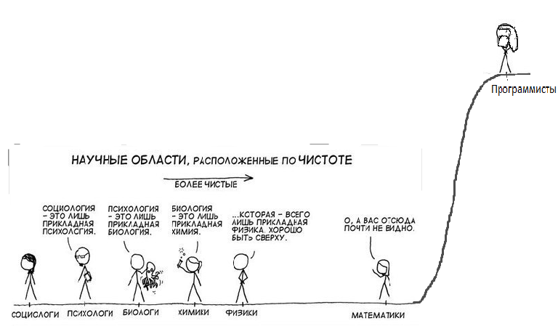

Logical means of knowledge
1. In any study, a scientist has to solve logical problems:
- what logical requirements must be met by reasoning that allows making objective and true conclusions; How to control the nature of this reasoning?
- What logical requirements should the description of empirically observed characteristics meet?
- How to logically analyze the initial systems of scientific knowledge, how to coordinate some knowledge systems with other knowledge systems (for example, in sociology and closely related psychology)?
- How to build a scientific theory that allows for scientific explanations, predictions, etc.?
Logical means of knowledge
The use of logical means in the process of constructing reasoning and evidence allows the researcher to separate controlled arguments from intuitively or uncritically accepted, false from true, confusion from contradictions.

Logical means of knowledge

1. The principle of induction states that: Observation of the phenomenon X, which corresponds to the theory of T, increases the probability that the theory of T is true.
2. Inductive conclusions are widely used in science. The opinion about the truth of many scientific laws (such as, for example, Newton's laws) is based on the fact that many observations confirm their truth, while there are no observations that contradict these laws (in those conditions where these laws should be applicable according to theory).
3. "Suppose there is a theory that all crows are black. According to formal logic, this theory is equivalent to the theory that all objects that are not black are not crows. If a person sees a lot of black ravens, then his confidence that this theory is correct will increase. If he sees a lot of red apples, then this will increase his confidence that all non-black objects

4. are not crows, and, according to the above, should also increase his confidence that all crows are black. " However, this conclusion contradicts the intuitive perception of the situation by man. Observing red apples will increase the observer's confidence that all non-black objects are not crows, but will not increase his confidence that all crows are black.
Sophism is a kind of logical conclusion in structure, proving an absurd or paradoxical statement that contradicts the generally accepted objective truth.
Modern sophism, justifying,
that with age the "years of life" not only seem,
but actually shorter:
"Every year of your life is its 1/second part, where p is the number of years you have lived. But p + 1 > p. Therefore, 1/p + 1 < 1/p. "

Language Tools of Knowledge
1. An important linguistic means of cognition are the rules for constructing definitions of concepts (definitions). In any scientific study, the scientist has to clarify the concepts, symbols and signs introduced, use new concepts and signs. Definitions are always associated with language as a means of learning and expressing knowledge.
2. The rules for using languages ​ ​ both natural and artificial, with the help of which the researcher builds his reasoning and evidence, formulates hypotheses, receives conclusions, etc., are the starting point for cognitive actions. Knowledge of them has a great impact on the effectiveness of the use of linguistic means of cognition in scientific research.
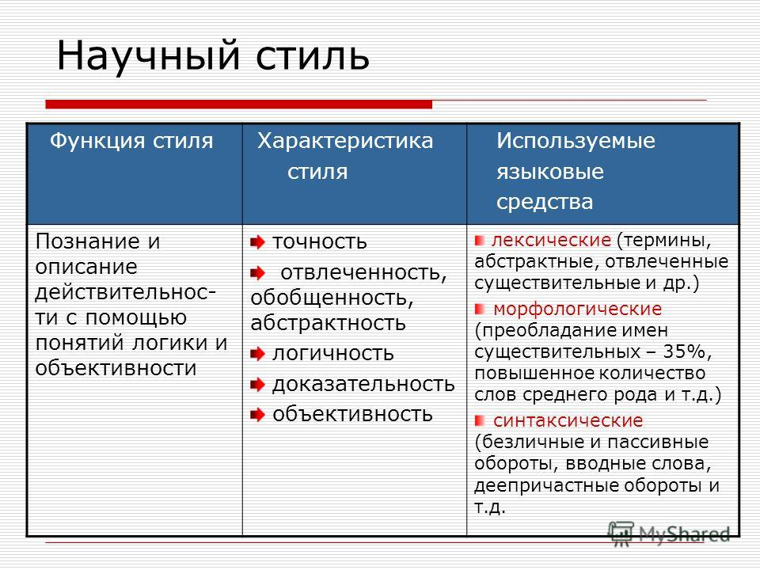

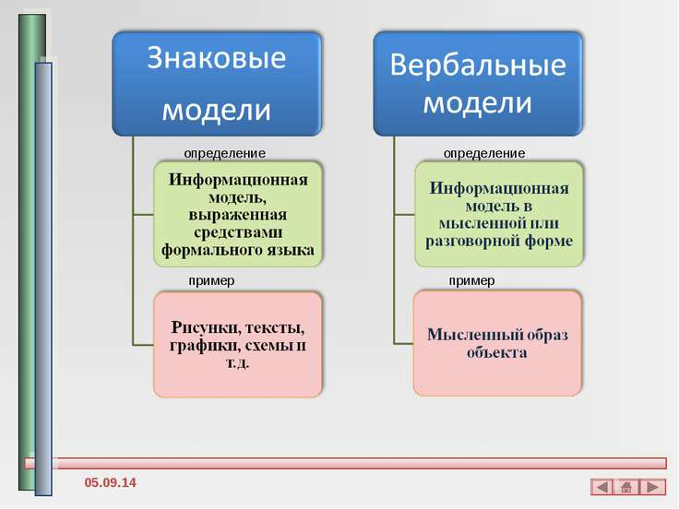

1. "The boundaries of my language mean the borders of my world" (L. Wittgenstein)
2. "In a word and through a word we will know reality, and the word is reality itself"
(P. Florensky)
3. "Language helps us to know the world in the same way as vision and hearing" (N. Chomsky)
4. "Truth cannot be transmitted in the same language"
(I. Garin)

Classification of scientific research methods
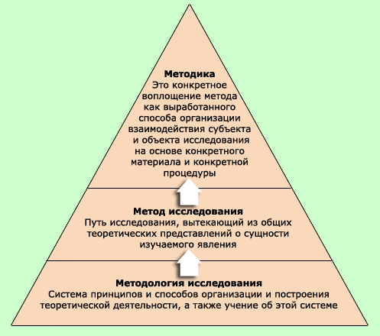

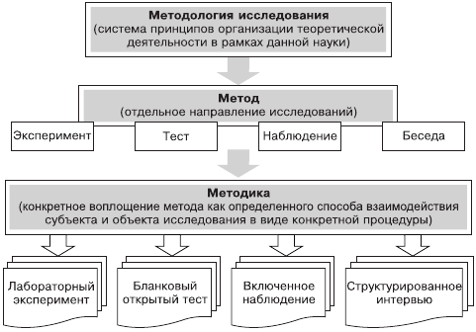
Definitions
1. Method (gr. Methodos) is 1) a way of knowing, studying the phenomena of nature and social life; 2) reception, method and mode of actions.
2. The scientific method is a system of rules and regulations that guide human activity (industrial, political, cultural, scientific, educational, etc.) to achieve the goal set.
3. If methodology is a strategy of scientific research that ensures the achievement of the goal formulated in the hypothesis of supposed scientific results (the general way of cognition), then the method is a tactic that shows how best to go this way.
4. Method (gr. Methodos) is 1) a way of knowing, studying the phenomena of nature and social life; 2) reception, method and mode of actions.
5. The scientific method is a system of rules and regulations that guide human activity (industrial, political, cultural, scientific, educational, etc.) to achieve the goal set.
6. If methodology is a strategy of scientific research that ensures the achievement of the goal formulated in the hypothesis of supposed scientific results (the general way of cognition), then the method is a tactic that shows how best to go this way.
No method gives the researcher a finished template
- Correct and adequate application of scientific methods is needed. As academician P. Kapitsa noted, the scientific method "seems to be the Stradivarius violin, the most perfect of violins, but in order to play it, you need to be a musician and know the music. Without this, she will be as fake as the usual violin. "
- 2. The method depends not so much on the object as on the subject. The researcher often has the question of choosing a research method. This choice is influenced by the level of scientific training of the researcher, experience of cognitive activity, etc. Therefore, subjective modifications of the method can arise on the basis of the same theory.

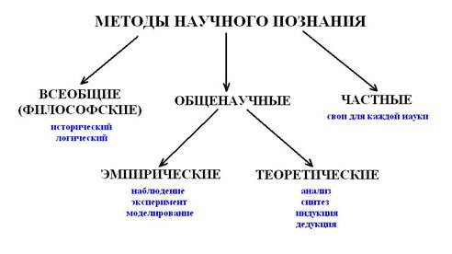

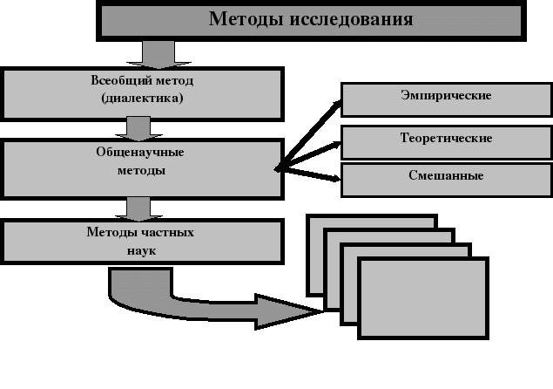
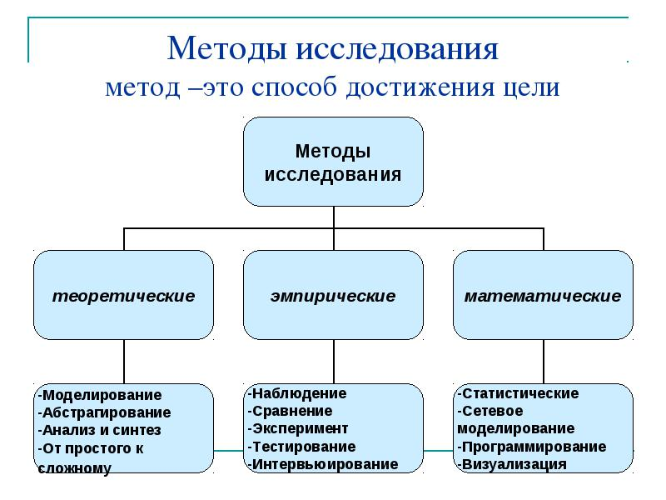

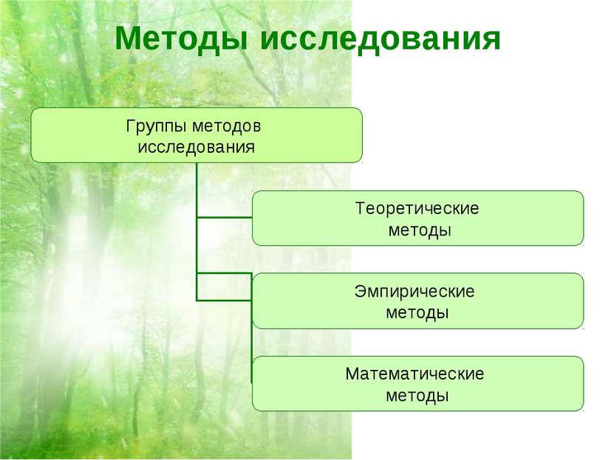
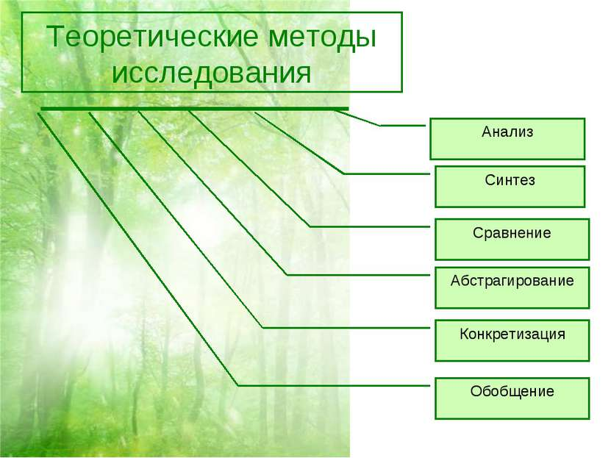
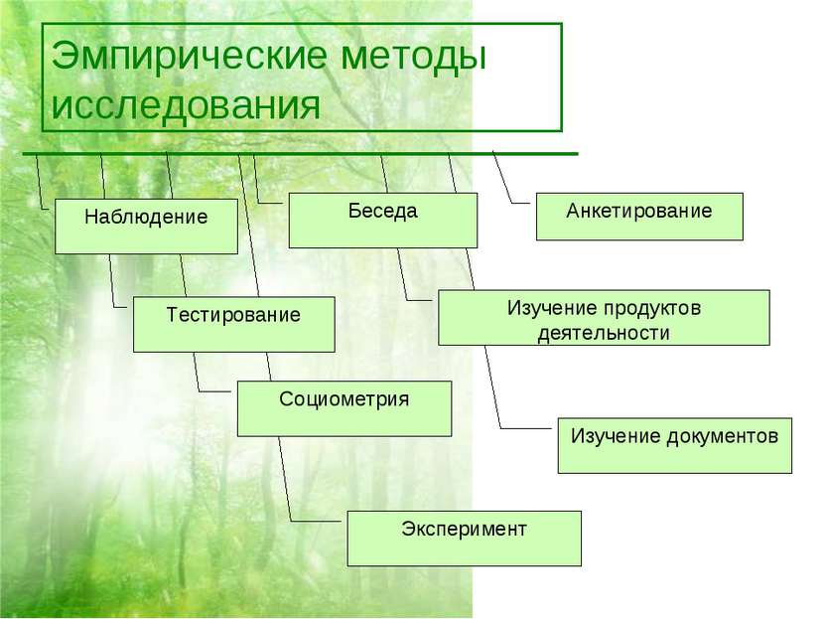
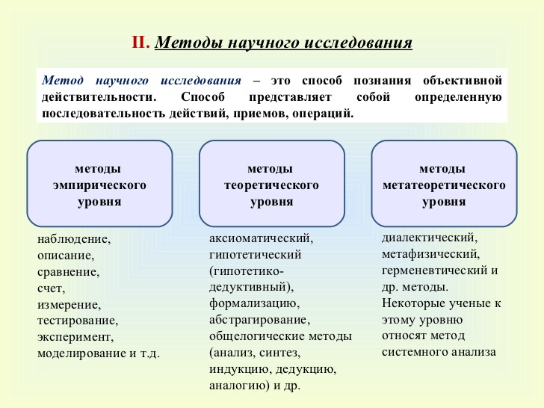

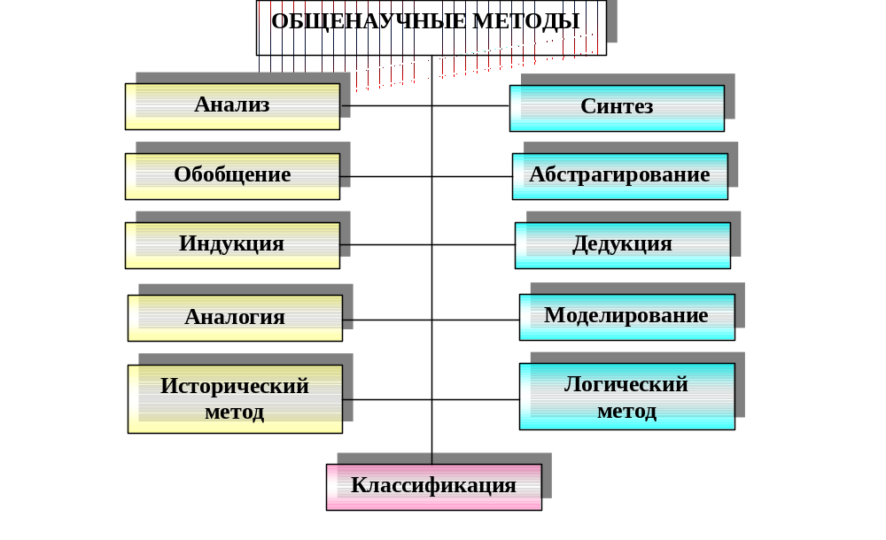

ТЕОРЕТИЧЕСКИЕ |  | ЭМПИРИЧЕСКИЕ
методы-операции | методы-действия | методы-операции | методы-действия
- • analysis  - • synthesis  - comparison  - • abstraction  - • concretization  - generalization  • formalization  • induction  • deduction  • idealization  • analogy  • modeling  • thought experiment  imagination | - • dialectics  - • scientific theories, proof  - • Knowledge Systems Analysis  - • deductive (axiomatic) method  - • inductive-deductive method  - • detection and resolution of contradictions  - • Problem-setting  - • hypothesis construction | - • study of literature, documents and results of activities  - • observation  - • measurement  - • Survey (oral and written)  - • expert assessments  - testing | - • methods of tracing an object (survey, monitoring, study and synthesis of experience)  - • methods of object transformation (experimental work, experiment)  - • methods for investigating an object over time (retrospective, prediction)

- Classification of methods
- dissertation study
- I. Search (before result)
- II. Receipt (at the time of obtaining the result)
- III. Justifications
- IV. Presentations
- Theoretical Methods-Operations
- 1. Theoretical "methods - operations" are determined by the main mental operations:
9. analysis and synthesis, comparison, abstraction and concretization, generalization, formalization, induction and deduction, idealization, analogy, modeling, thought experiment.

Theoretical Methods-Operations
1. Analysis is the decomposition of the studied integer into parts, the isolation of individual features and qualities of a phenomenon, process or relations of phenomena, processes. Analysis procedures are an organic component of any scientific study and usually form its first phase, when the researcher moves from an unparalleled description of the object being studied to the identification of its structure, composition, properties and features.
2. The same phenomenon, the process can be analyzed in many aspects. A comprehensive analysis of the phenomenon allows a deeper consideration of it.
3. Synthesis is the connection of various elements, sides of an object into a single whole (system). Synthesis is not a simple summation, but a semantic compound.
4. The synthesis is opposite to the analysis with which it is inextricably linked. Synthesis as a cognitive operation acts in various functions of theoretical research. Any process of concept formation is based on the unity of analysis and synthesis processes. Empirical data obtained in a particular study are synthesized by their theoretical generalization.
5. In theoretical scientific knowledge, synthesis acts as a function of the relationship of theories related to one subject area, as well as the function of combining competing theories, for example, the synthesis of corpuscular and wave representations in physics).
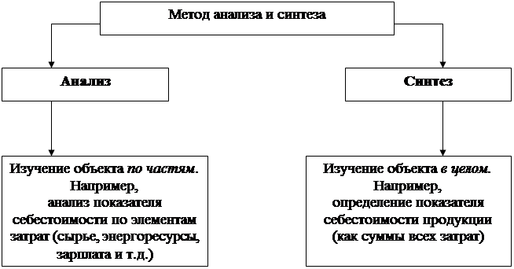
Theoretical Methods-Operations
1. Comparison is a cognitive operation that underlies judgments about the similarity or difference of objects. Using comparison, quantitative and qualitative characteristics of objects are detected, their classification, ordering and evaluation are carried out.
2. A comparison is a mapping of one to another. In this case, the bases, or comparison features, that determine the possible relationships between objects play an important role.

Theoretical Methods-Operations
1. Abstraction is one of the main thought operations that allows you to mentally isolate and turn into an independent object of consideration individual parties, properties or states of an object in pure form. Abstraction is at the heart of the processes of generalization and formation of concepts.
2. Such isolation is possible only in mental terms - in abstraction. So, the geometric shape of the body itself does not really exist and cannot separate from the body. But thanks to abstraction, it mentally stands out, is fixed, for example, using a drawing, and is independently considered in its specific properties.
3. Concretization is a process opposite to abstraction, that is, finding a holistic, interconnected, multilateral and complex. The researcher initially forms various abstractions, and then on their basis, by concretization, reproduces this integrity (mental specific), but already at a qualitatively different level of cognition of a particular one.
4. The dialectic of theoretical thinking consists in the unity of abstraction, the creation of various abstractions and concretization, the movement to a particular one and the reproduction of it.
5. Generalization is one of the main cognitive thought operations, consisting in the isolation and fixation of relatively stable, invariant properties of objects and their relationships
6. Generalization allows you to display the properties and relationships of objects, regardless of the private and random conditions of their observation. The separation of general properties from private properties and the designation of them with the word allows in abbreviated, compressed form to cover the entire variety of objects, to reduce them to certain classes, and then, through abstractions, to operate with concepts without directly referring to individual objects.
7. The function of generalization is to organize the variety of objects, their classification.
8. Formalization - Display the results of thinking in precise concepts or statements. It is kind of a thought operation of the "second order." Formalization is opposed to intuitive thinking. In mathematics and formal logic, formalization means the display of meaningful knowledge in a sign form or in a formalized language.
9. Formalization, that is, the distraction of concepts from their content, ensures the systematization of knowledge, in which individual elements of it coordinate with each other. True science is possible only on the basis of abstract thinking, consistent reasoning of the researcher, flowing in a logical linguistic form through concepts, judgments and conclusions.
10. Scientific judgments establish links between objects, phenomena or between their certain features. In scientific conclusions, one judgment comes from another, on the basis of existing conclusions, a new one is made. There are two main types of leads: inductive (induction) and deductive (deduction).
11. Induction is the conclusion from private objects, phenomena to the general conclusion, from individual facts to generalizations.
12. Deduction is the conclusion from general to private, from general judgments to private conclusions.
13. Analogy (modeling) is a thought operation when knowledge obtained from the consideration of one object (model) is transferred to another, less studied or less accessible to study, less visible object, called a prototype, original. It is possible to transfer information by analogy from the model to the prototype.
14. This is the essence of one of the special methods of the theoretical level - modeling (model construction and research). The difference between analogy and modeling is that if the analogy is one of the thought operations, then modeling can be considered in different cases both as a thought operation and as an independent method - method-action.
15. Cognitive methods-actions include: dialectics, scientific theories, proof, analysis of knowledge systems, deductive (axiomatic) method, inductive-deductive method, problem setting, hypothesis construction.
16. The laws of dialectics: the transition of quantitative changes to qualitative, unity and the struggle of opposites, etc.; analysis of paired dialectical categories: historical and logical, phenomenon and essence, general (universal) and single, etc., are integral components of any competently constructed scientific research.
17. Scientific theories proven by practice: any such theory essentially acts as a function of the method when constructing new theories in a given or even in other areas of scientific knowledge, as well as in the function of the method that determines the content and sequence of the experimental activity of the researcher.
18. Proof is a theoretical (logical) action in the process of which the truth of any thought is substantiated using other thoughts. All evidence consists of three parts: thesis, arguments (arguments) and demonstration. According to the method of conducting evidence, there are direct and indirect, in the form of inference - inductive and deductive.
19. The deductive method (synonym - axiomatic method) is a method of constructing a scientific theory, in which it is based on some initial positions of the axiom (synonym - postulates), from which all other provisions of this theory (theorems) are derived purely by logical means of proof.
20. Inductive deductive method: first, an empirical basis is accumulated, on the basis of which theoretical generalizations (induction) are built, which can be built up in several levels - for example, empirical laws and theoretical laws - and then these obtained generalizations can be extended to all objects and phenomena covered by this theory (deduction).
21. The hypothetical method of cognition involves the development of a scientific hypothesis based on the study of the physical, chemical, etc., the essence of the investigated phenomenon, the formulation of the hypothesis, the compilation of the calculation scheme of the algorithm (model), its study, analysis, the development of theoretical positions.
22. The historical method of cognition involves the study of the emergence, formation and development of objects in a chronological sequence.

Control questions
1. Give examples of material, informational, mathematical, logical, linguistic means of knowledge.
2. What is the "scientific method"?
3. How do we classify methods of scientific knowledge?
4. Name the main theoretical methods of research. Which of these do you expect to use at various stages of scientific research?
5. What is the peculiarity of specifically scientific methods in comparison with general scientific methods? Give examples.
6. Give examples of operation methods and action methods.
7. What mathematical methods are the most used in scientific works?
8. What is required to determine the methods of future research?
9. Do you think the list of methods used in various studies is being updated? What does it depend on?
10. Can there be such a scientific fact for the study of which general scientific methods are not suitable?

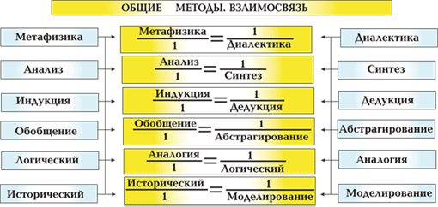

Classification of scientific methods

Philosophical:
▪ metaphysical
▪ dialectical
▪ phenomenological
▪ hermeneutic
II. General scientific:
▪ empirical
▪ theoretical
▪ General
III. Private science
IV. Disciplinary.
V. Interdisciplinary.

